**مبادرة رواد مصر الرقمية**

**(2025-2026)**

**SQL Server**

**[Examination System Database]**

**Documentation**

# **Project Teamwork**



|  |  |
| --- | --- |
| No | Name |
|  | **محمود عقل محمود** |
|  | **(Leader): عبد الرحمن علاء السيد** |
|  | **محمد عادل فتحي** |

**Table of Contents**

Contents

* Project Teamwork
* System Requirements
* ERD Diagram
* **SQL Server script file for all database structure, objects and data**
* **Text file containing name and brief description for all objects in DB**
* **Test sheets that contain test queries, its result and comment.**
* **Text file contains all accounts for the database and passwords.**

**System requirements**

1) System should provide question pool, so instructor can pick an exam from it.

2) Questions type may be Multiple choice, True & false or text questions.

3) For multiple choice and true & false questions system should store correct answer and check

student answer and store his result.

4) For text question system should store best accepted answer and use text functions and regular

expression to check student answer and display result to the instructor show him valid answers

and not valid answers to review them and enter the marks manually (Bonus).

5) System should store courses information (Course name, description, Max degree, Min Degree),

instructors’ information, and students’ information, each instructor can teach one or more course,

and each course may be teacher by one instructor in each class (Instructor may be changed for

other class in other year).

6) Training manager can add and edit: Branches, tracks in each department, and add new intake.

7) Training manager can add students, and define their personal data, intake, branch, and track.

8) Training manager, Instructors, Students should have a login account to access the system.

9) Instructor can make Exam (For his coLurse only) by selecting number of questions of each type,

the system selects the questions random, or he can select them manually from question pool.

And he must put a degree for each question on the exam, and total degrees must not exceed the

course Max Degree (One course may has more than one exam).

For each exam, we should know type (exam or corrective), intake, branch, track, course, start

time, End time, total time and allowance options.

10) System should store each exam which defined by year, Course, instructor.

11) Instructor can select students that can do specific exam, and define Exam date, start time and end

time. Students can see the exam and do it only on the specified time.

12) System should store students answer for the exam and calculate the correct answers, and

calculate final result for the student in this course.

13) Insert test data in all tables and test your system.

**🡺🡺🡺** [**https://2u.pw/qXAso**](https://2u.pw/qXAso)

**ERD**

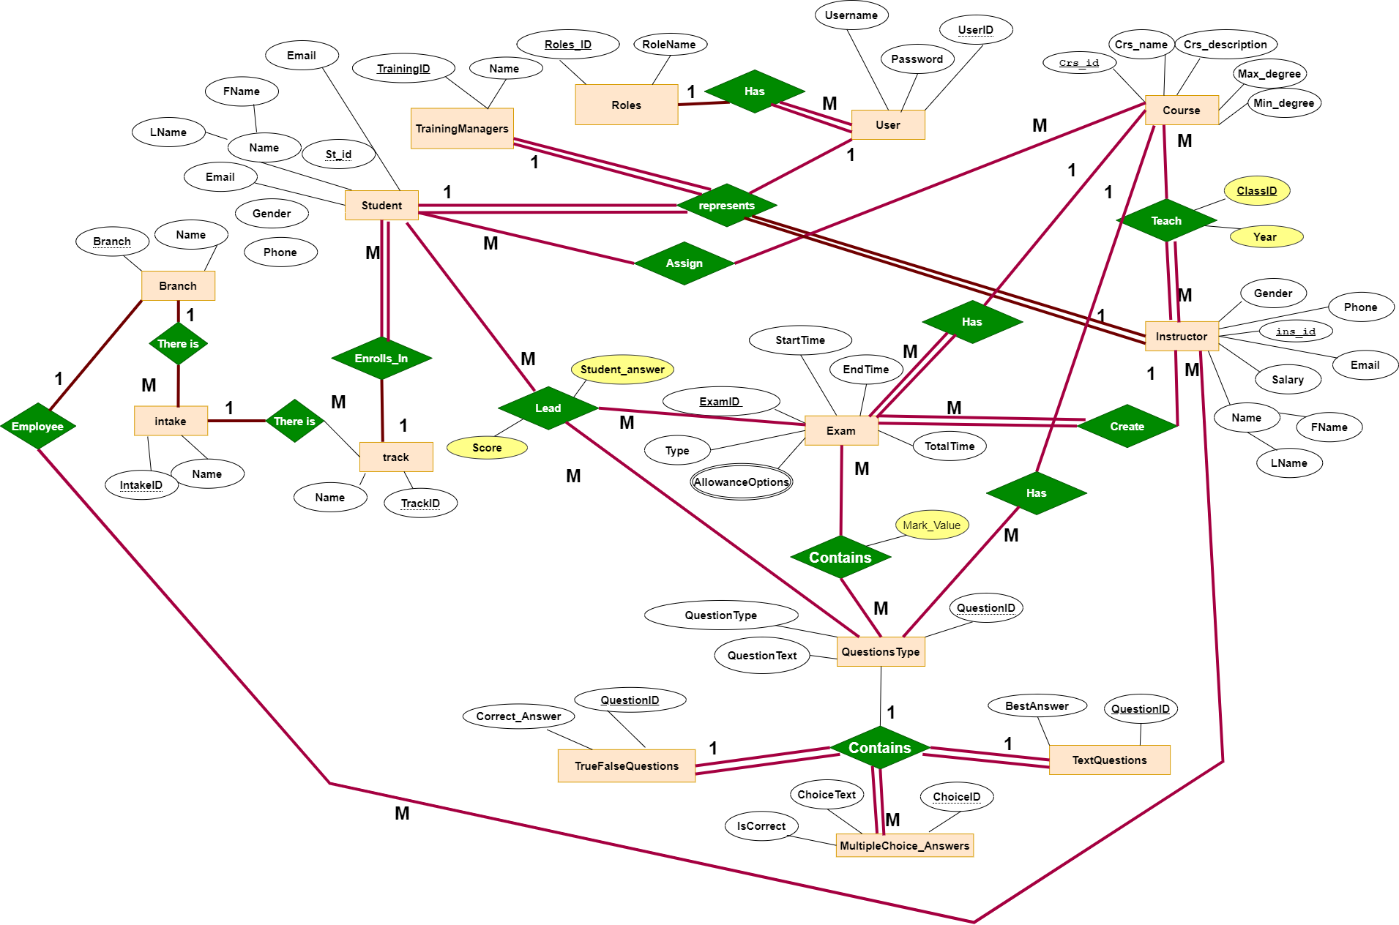

**Tables with Schema**

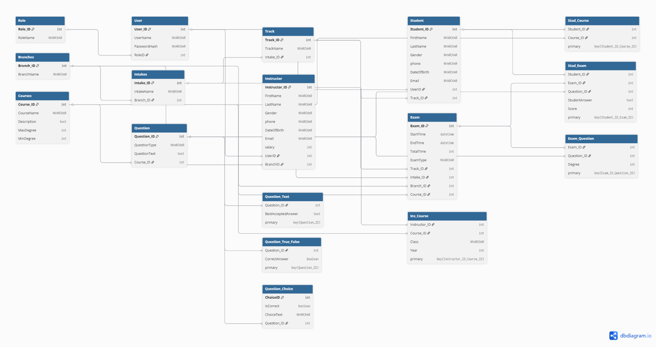**🡺🡺**[**https://dbdiagram.io/d/68779227f413ba35082a51a3**](https://dbdiagram.io/d/68779227f413ba35082a51a3)

**Files on GitHub link:** [**https://github.com/Akl-n1/Examination-System-Database.git**](https://github.com/Akl-n1/Examination-System-Database.git)

**Database File**

### 

### 1. [TrainingManager].[VW_BranchReport]

**Purpose:**  
Provides a statistical summary for each branch, including the number of intakes, tracks, instructors, students, courses, and exams associated with the branch.

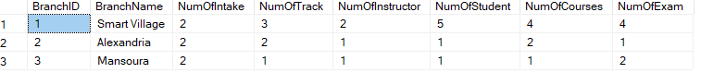

### 2. [TrainingManager].[VW_IntakeReport]

**Purpose:**  
Provides a detailed report for each intake, showing the associated track, branch, and counts of instructors, students, courses, and exams linked to that intake.

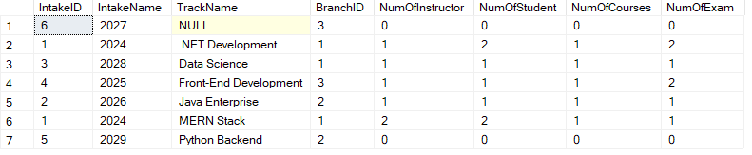

### 3. [TrainingManager].[VW_TrackReport]

**Purpose:**  
Displays detailed statistics for each track, including its intake, branch, and the count of associated instructors, students, courses, and exams.

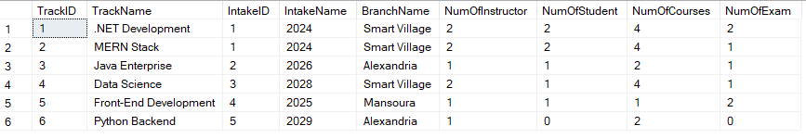

### 4. [TrainingManager].[VW_CoursesReport]

**Purpose:**  
Summarizes each course with description, max/min degrees, and counts of students, instructors, and related exams.

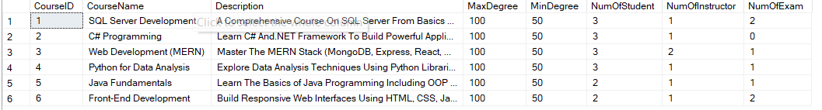

**-----**

### 5. [TrainingManager].[VW_InstructorReport]

**Purpose:**  
Shows full instructor details such as name, age, contact info, branch, assigned class/year, and course name.

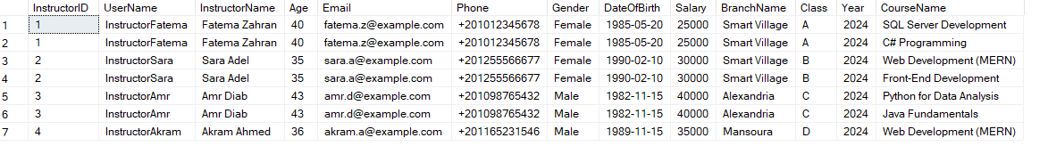

### 7. [TrainingManager].[VW_StudentReport]

**Purpose:**  
Summarizes student profiles with full name, age, gender, contact info, and associated branch, intake, and track.

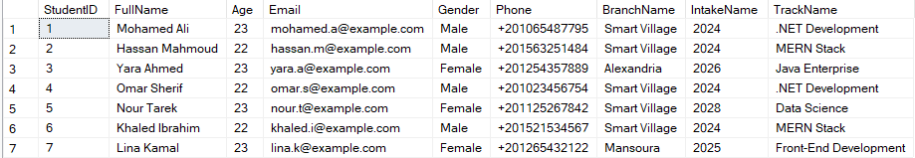

### 8. [TrainingManager].[VW_AllExamsReport]

**Purpose:**  
Gives an overview of all exams, showing course, exam type, schedule, status (e.g., Upcoming, In-Progress), instructor, and track.

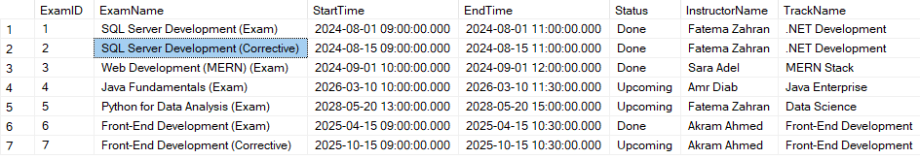

### 9. [TrainingManager].[VW_StudentReportMore]

**Purpose:**  
Extends student details with username, first/last name, date of birth, course, track, intake, and branch.

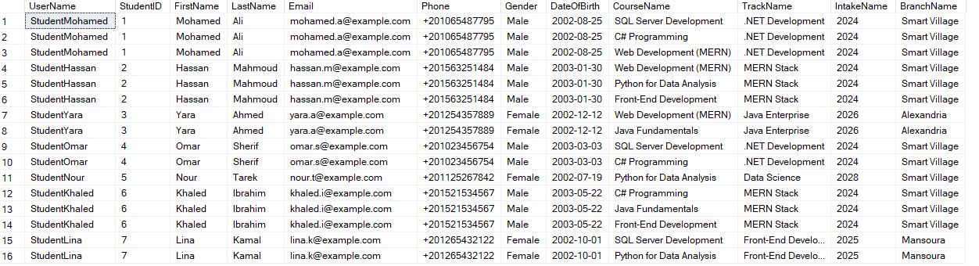

### 11. [TrainingManager].[VW_SystemSummaryReport]

**Purpose:**  
Presents a high-level summary of the entire system, including counts of branches, intakes, tracks, courses, students, instructors, exams, and questions.

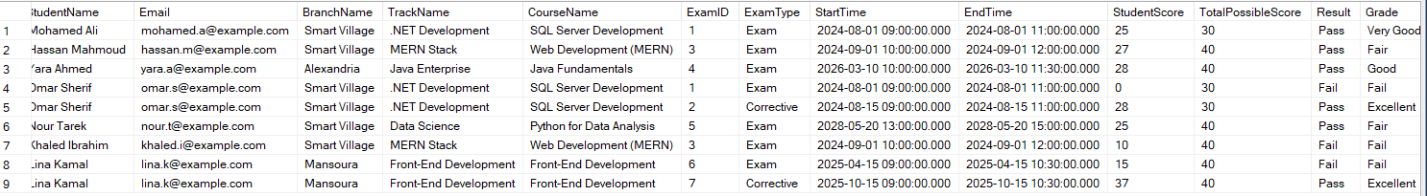

### 12. [TrainingManager].[VW_QuestionReport]

**Purpose:**  
Provides insights about each question’s usage, including its course, type, usage status, times used in exams, preview of text answers, and number of students who answered it.

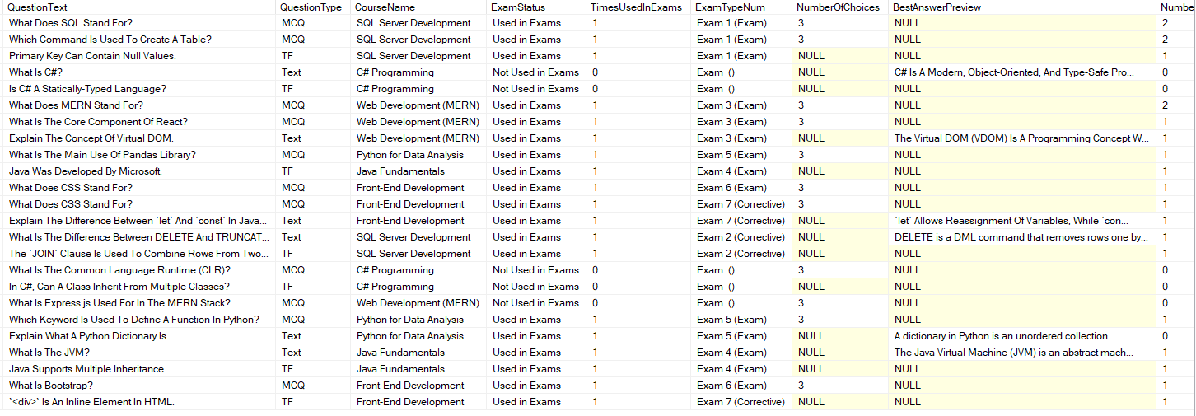

### 13. [TrainingManager].[VW_CourseQuestionPool]

**Purpose:**  
Lists all questions per course with their IDs, texts, and types, forming a question bank by course.

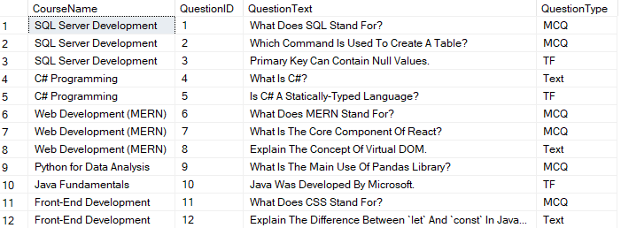

**1. [Instructor].[VW_MyProfile]**  
**Purpose:**  
Displays the profile of the currently logged-in instructor, including personal information, assigned courses, and class details..



**2. [Instructor].[VW_MyStudents]**  
**Purpose:**  
Lists all students assigned to the currently logged-in instructor, including their names, emails, and tracks.

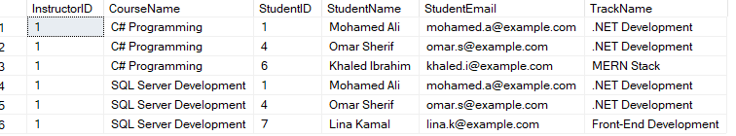

**3. [Instructor].[VW_MyCourses]**  
**Purpose:**  
Shows all courses taught by the currently logged-in instructor, along with descriptions, degrees, class info, and number of enrolled students.



**4. [Instructor].[VW_MyStudentsResults]**  
**Purpose:**  
Displays each student’s total score per exam created by the logged-in instructor, along with the total possible score.

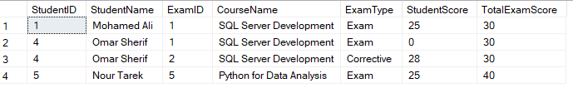

**5. [Instructor].[VW_MyExams]**  
**Purpose:**  
Shows all exams created by the instructor, with their status (Upcoming, In-Progress, Done), time range, and number of students who took them.



**6. [Instructor].[VW_MyQuestions]**  
**Purpose:**  
Lists all questions created by the instructor, categorized by course and type.

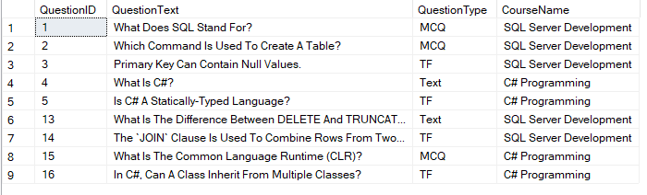

**7. [Instructor].[VW_MyQuestionsWithAnswers]**  
**Purpose:**  
Displays each question with its correct answer. For MCQs, also lists all choices in a formatted string.

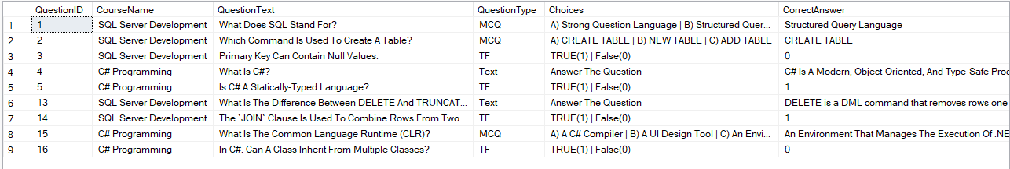

**8. [Instructor].[VW_MyStudentsAnswersDetails]**  
**Purpose:**  
Shows detailed answer information per student per question in exams conducted by the instructor, including score and student answer.

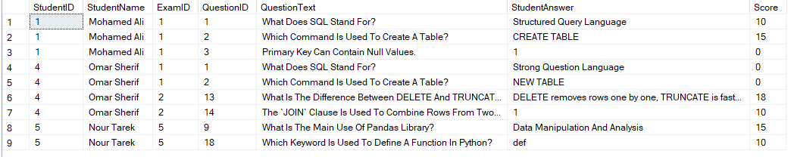

**9. [Instructor].[VW_MyUnusedQuestions]**  
**Purpose:**  
Lists all questions created by the instructor that haven’t been used in any exam yet, including course and type, and number of choices for MCQs.

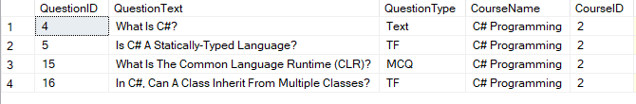

### 1. [Student].[VW_MyProfile]

**Purpose:**  
Displays the profile of the currently logged-in student, including personal information (name, email, phone) and academic details (track, intake, branch).

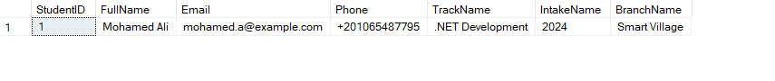

### 2. [Student].[VW_AvailableExams]

**Purpose:**  
Displays all available exams (upcoming or in-progress) for the currently logged-in student, showing exam details, course name, instructor name, time, and current exam status.



### 3. [Student].[VW_MyResults]

**Purpose:**  
Displays the exam results of the currently logged-in student, including score, total degree, pass/fail status, and course information for each exam taken.



**Stored Procedure**

### 1. [Admin].[SP_LoginForUser]

**Purpose:**  
Creates a SQL Server login, database user, and assigns the user to the appropriate role in the database based on the application’s internal Role table.

### 2. [Admin].[SP_EditUser]

**Purpose:**  
Updates a user's username, password hash, or role ID in the application’s User table, with proper validation checks to prevent data conflicts or invalid roles.

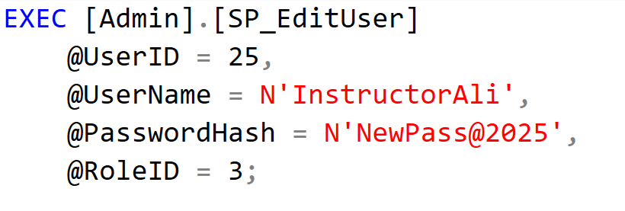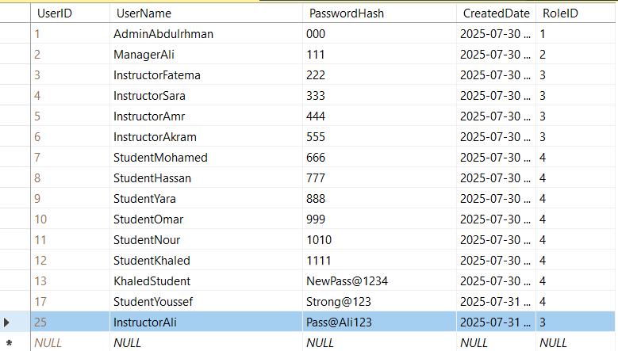

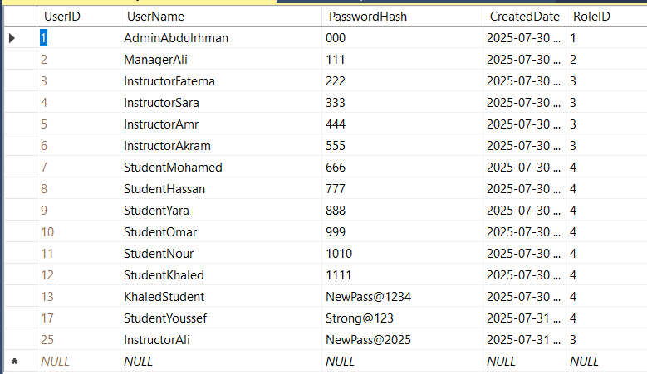

### 3. [Admin].[SP_DeleteUser]

**Purpose:**  
Completely deletes a user from the system, including all related data (exams, answers, course links, etc.), whether the user is an instructor or a student.

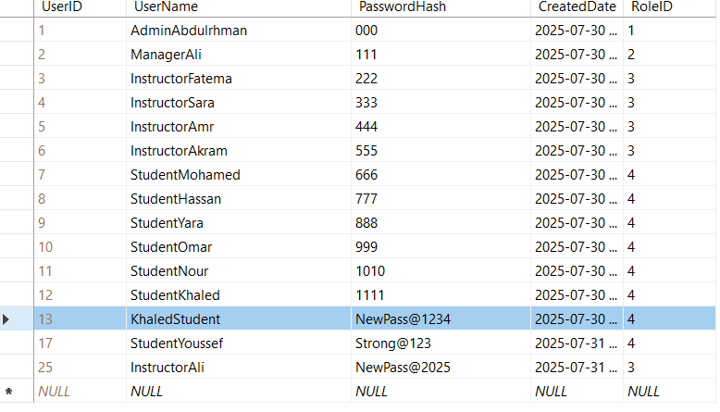

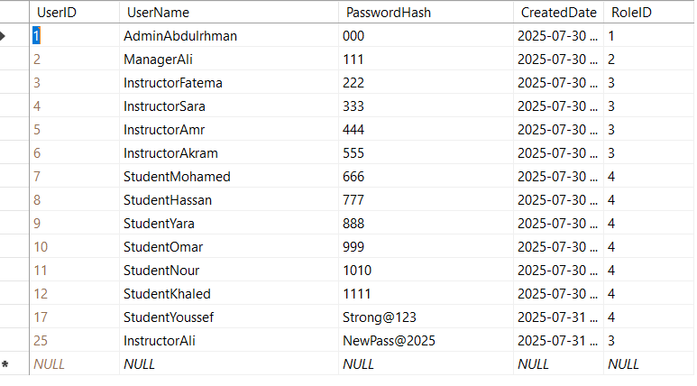

1. **[TrainingManager].[SP_AddNewStudent]**  
   **Purpose:**  
   Adds a new student to the system by creating a user account in the [User] table and then inserting the student's personal information into the Student table. The procedure ensures data integrity through validation and uses a transaction to maintain consistency.
2. 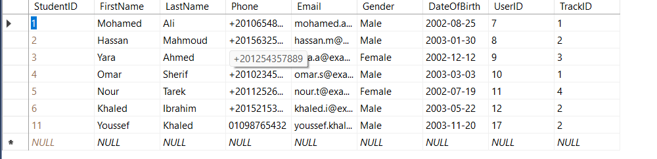

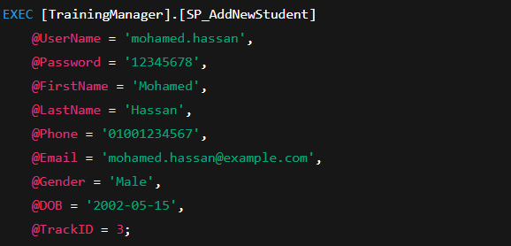

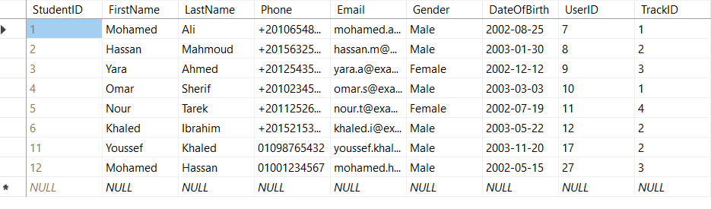

### 4. [TrainingManager].[SP_AddNewInstructor]

**Purpose:**  
Adds a new instructor to the system, including creating a user account and inserting instructor profile details, in a safe, transactional way.

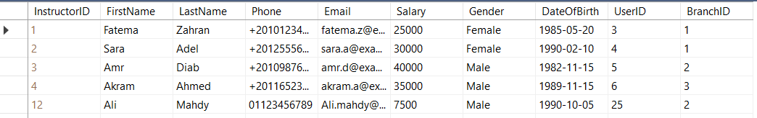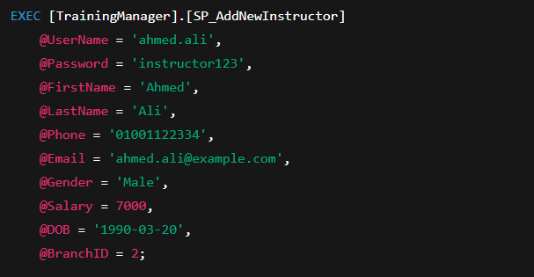

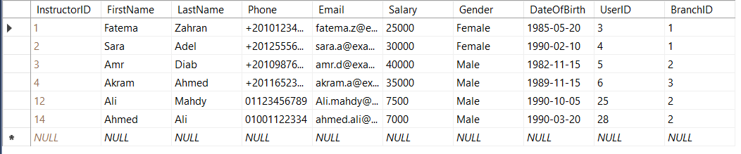

**----------------------------------**

### 5. [TrainingManager].[SP_AddNewBranch]

**Purpose:**  
Adds a new training branch to the system, after verifying the name doesn't already exist, within a safe transaction.

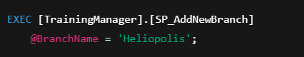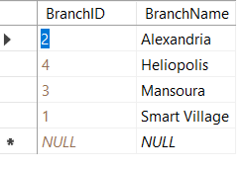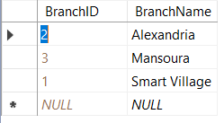

### 6. [TrainingManager].[SP_AddNewIntake]

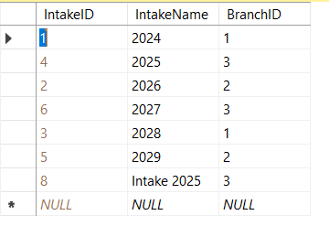**Purpose:**  
Adds a new intake (student group) to a specific branch, ensuring no duplicate intake name exists within the same branch.

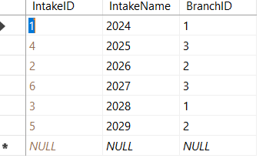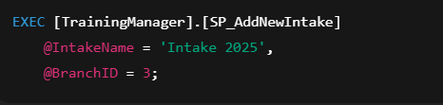

### 7. [TrainingManager].[SP_AddNewTrack]

**Purpose:**  
Adds a new track (specialization) under a specific intake, while preventing duplicate track names within the same intake.

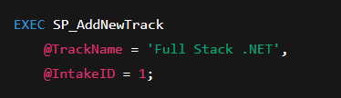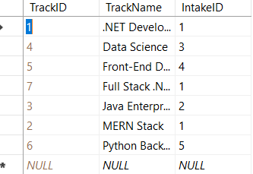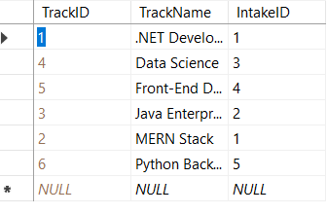

**---------------------------------------------------------------------------**

### 8. [TrainingManager].[SP_AddNewCourse]

### **Purpose:** Adds a new course with name, optional description, and validation rules for Max/Min degrees.

### 

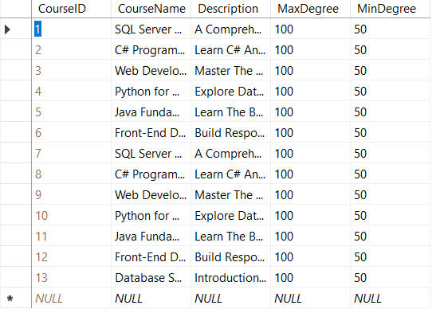

### 9. [TrainingManager].[SP_DeleteStudent]

**Purpose:**  
Safely deletes a student by ID, including related course enrollments and exam answers.

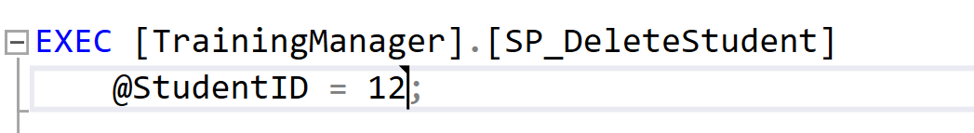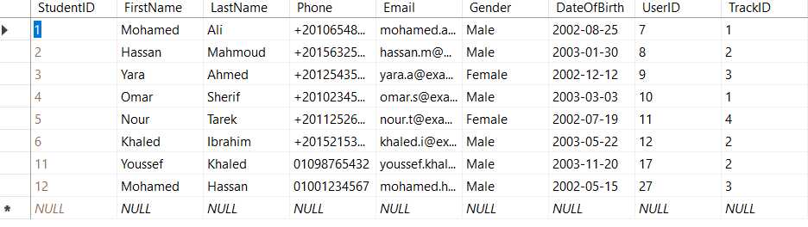

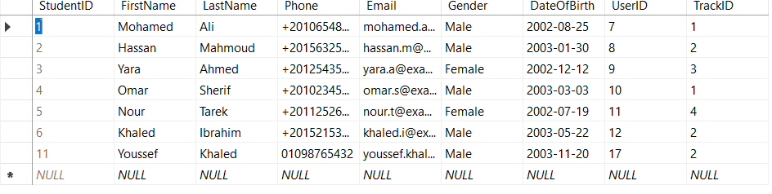

### 10. [TrainingManager].[SP_DeleteInstructor]

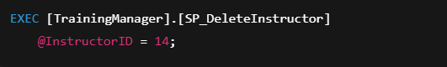**Purpose:**  
Safely deletes an instructor and all related data including their exams, questions, and assigned courses.

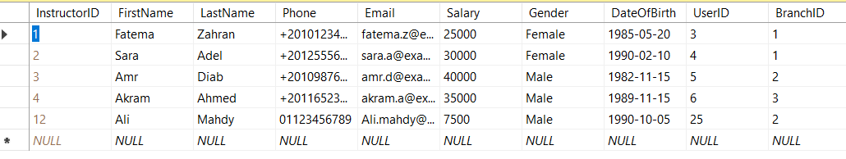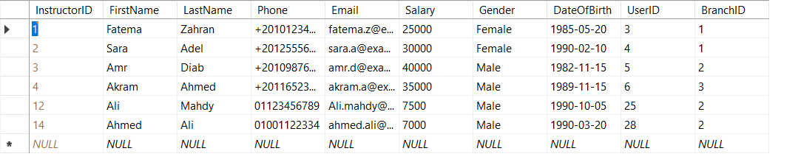

### 11. [TrainingManager].[SP_DeleteCourse]

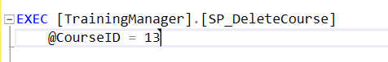**Purpose:**  
Completely removes a course from the system along with all its related data (exams, questions, answers, instructor/student assignments), while preserving referential integrity.

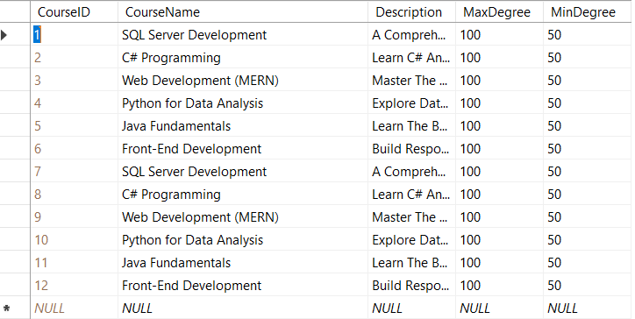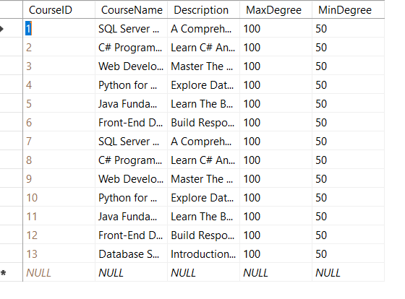

### 12. [TrainingManager].[SP_DeleteTrack]

**Purpose:**  
Deletes a track and all related data including students, exams, questions, and student-course associations—ensuring full cleanup in a safe transaction.

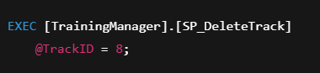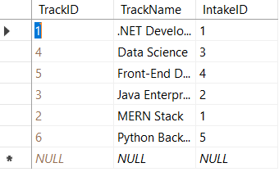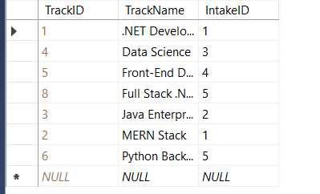

13.[TrainingManager].[SP_DeleteBranch]  
**Purpose:**  
Deletes a branch and all related data including its intakes, tracks, instructors, students, exams, student answers, and course registrations.

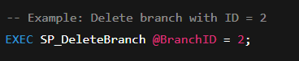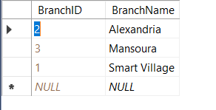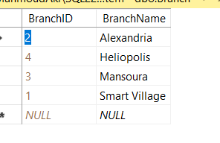

**14. [TrainingManager].[SP_DeleteIntake]**  
**Purpose:**  
Deletes an intake and all related tracks, students, exams, answers, and course registrations.

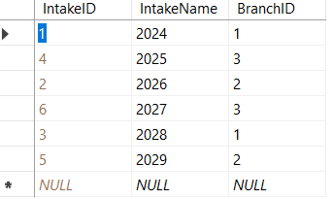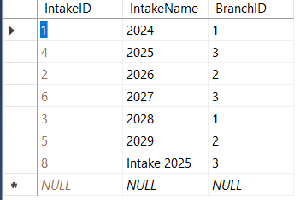



**15. [TrainingManager].[SP_DeleteExam]**  
**Purpose:**  
Deletes an exam and its related student answers and exam questions, only if the exam exists.

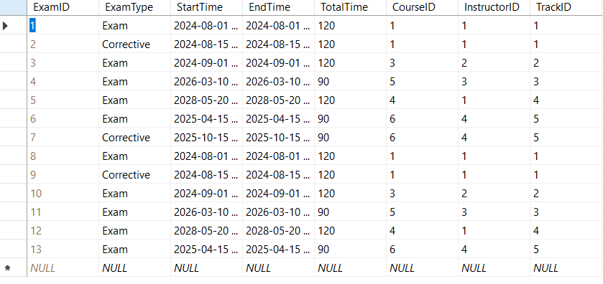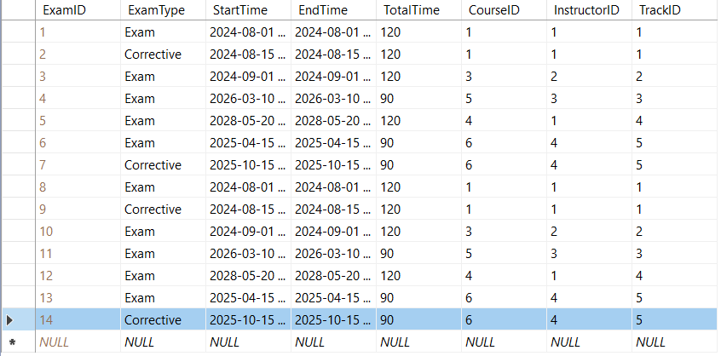



**16. [TrainingManager].[SP_EditBranch]**  
**Purpose:**  
Updates the name of a branch, with validation against duplicates and non-existent branches.

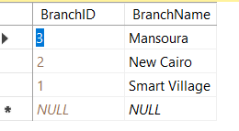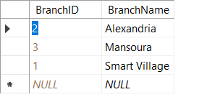



### **17. [TrainingManager].[SP_EditIntake]** **Purpose:** Edits intake name and/or branch, with validations on uniqueness and branch existence.

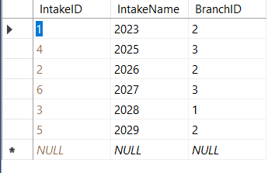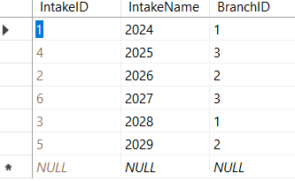

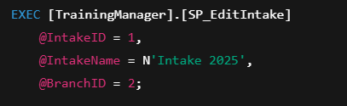

**18. [TrainingManager].[SP_EditTrack]**  
**Purpose:**  
Updates the name and/or intake of a track, with validations on duplicates and intake existence.

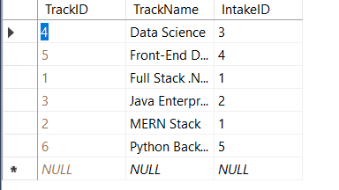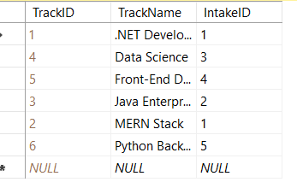



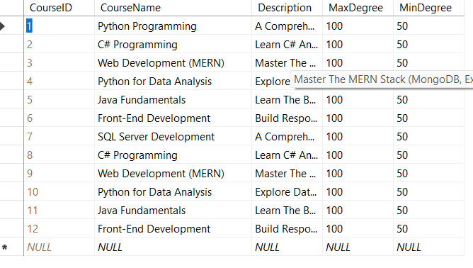**19. [TrainingManager].[SP_EditCourse]**  
**Purpose:**  
Updates course details like name, description, max/min degrees, with proper validation.

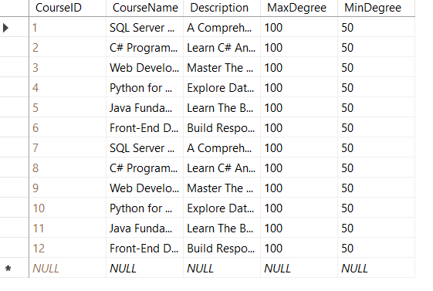



**20. [TrainingManager].[SP_EditInstructor]**  
**Purpose:**  
Edits instructor info including name, contact, gender, birth date, and branch, with validations.

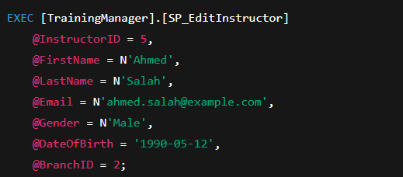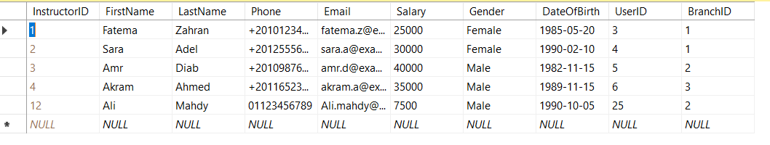

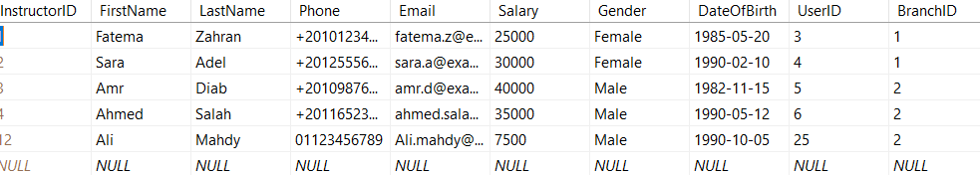

--------------------------------------------------------------------------------------------------------------------------------

**21. [TrainingManager].[SP_EditStudent]**  
**Purpose:**  
Updates student information including name, contact, gender, birth date, and track, with validations.

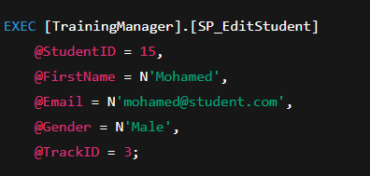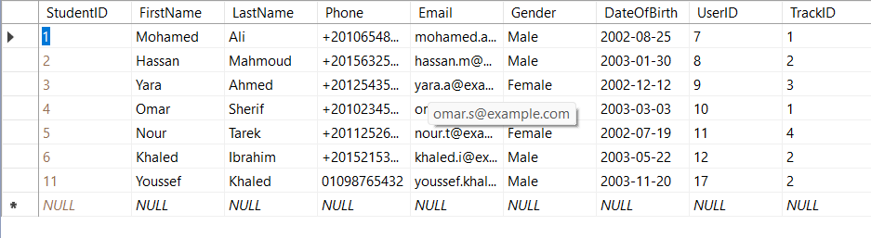

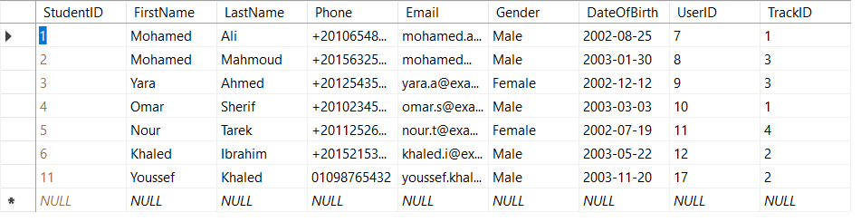

**22. [TrainingManager].[SP_EnrollStudentInCourse]**  
**Purpose:**  
Enrolls a student in a course if both exist and not already enrolled.

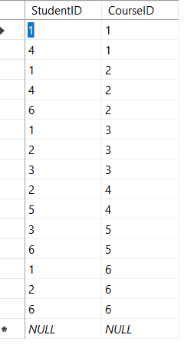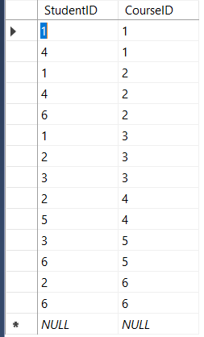



### **23. [TrainingManager].[SP_AssignInstructorToCourse]** **Purpose:** Assigns an instructor to a course for a specific class and year, with duplicate prevention.

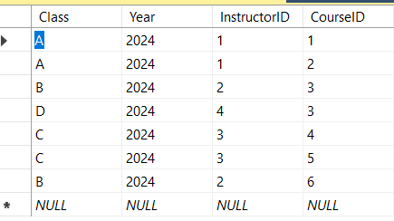

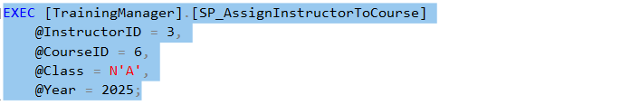

**14. [Instructor].[SP_AddMCQQuestion]**  
**Purpose:**  
Adds a new multiple-choice question (MCQ) for a course assigned to the current instructor. Validates course existence, instructor assignment, and correct answer format.

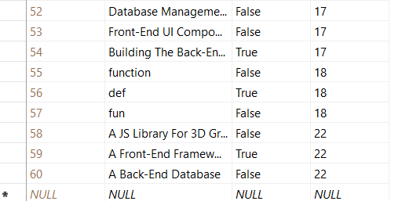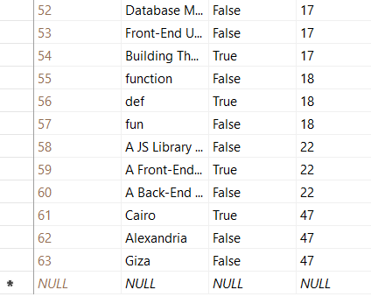

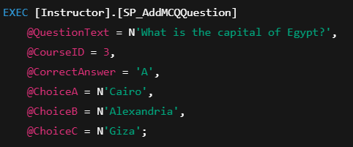

**14. [Instructor].[SP_AddTrueFalseQuestion]**  
**Purpose:**  
Adds a new True/False question to a course if the current instructor is assigned to it.

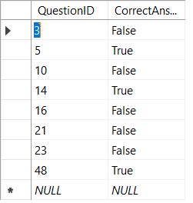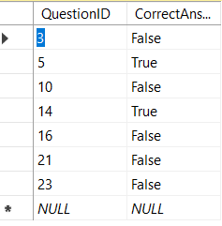

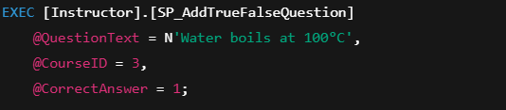

**15. [Instructor].[SP_AddTextQuestion]**  
**Purpose:**  
Adds a new open-ended text question to a course if the current instructor is assigned to it.

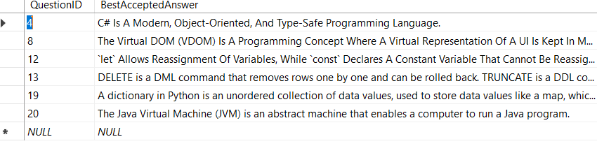

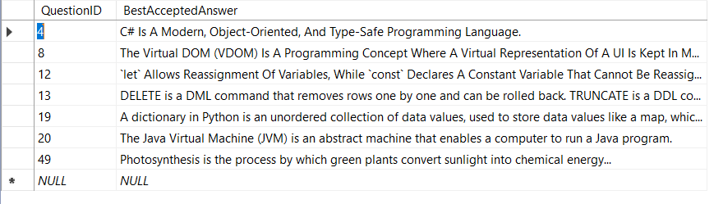

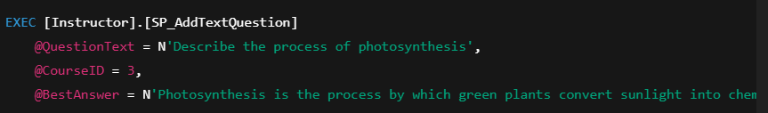

**16. [Instructor].[SP_InstructorCreateExamManually]**  
**Purpose:**  
Allows an instructor to manually create an exam with custom questions and assigned degrees.

**17. [Instructor].[SP_GetUnGradedTextAnswers]**  
**Purpose:**  
Retrieves all ungraded text answers submitted by students for exams created by the currently logged-in instructor.

**18. [Instructor].[SP_GradeTextAnswer]**  
**Purpose:**  
Allows an instructor to assign a score to a student's answer for a specific text question in an exam they created.

**19. [Instructor].[SP_GetRandomQuestions]**  
**Purpose:**  
Retrieves a random set of questions (MCQ, True/False, and Text) for a given course, only if the instructor is assigned to teach that course.

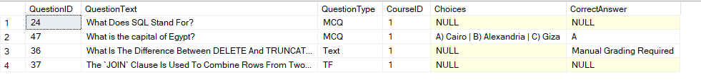

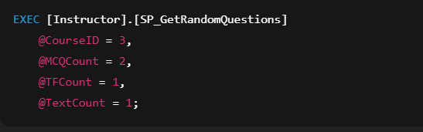

• **22. [Instructor].[SP_EditQuestion]**

• **Purpose:** Allows an instructor to edit the text of a question only if it hasn’t been used in any exam

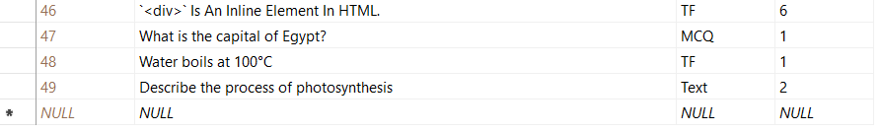

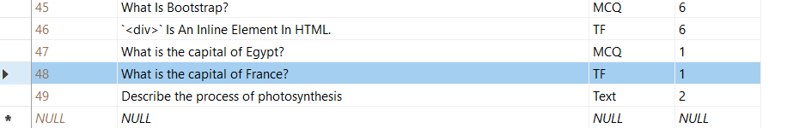

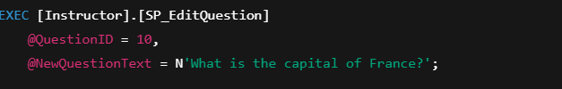

**23. [Instructor].[SP_DeleteQuestion]**

• **Purpose:** Deletes a question (and its related data) if it’s not used in any exam and belongs to one of the instructor's courses.

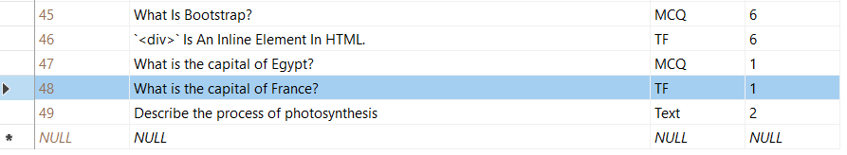

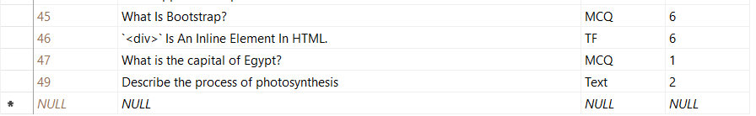



**---------------------------------------------------------------------------------**

**25. [Student].[SP_GetMyExamGrade]**

• **Purpose:** Retrieves the student's grade details for a specific exam, including score, total degree, and pass/fail status.

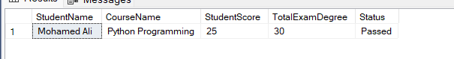

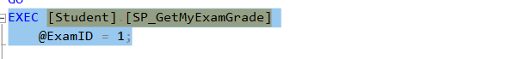

24. [Student].[SP_SubmitMyAnswer]

• **Purpose:** Allows a student to submit or update their answer for a specific question in a given exam, only if the exam is currently active and the student is enrolled in the exam’s track.

----------------------------------------

• 25. [Student].[SP_EnterExam]

• **Purpose:** Allows a student to enter an active exam and view the questions along with their choices (for MCQ/TF types), ensuring the student is enrolled in the correct track and within the allowed exam time.

**عبد الرحمن علاء السيد:**

|  |  |  |
| --- | --- | --- |
| Stored Procedure Name | Schema | Type |
| SP_LoginForUser | Admin | Stored Procedure |
| SP_EditUser | Admin | Stored Procedure |
| SP_DeleteUser | Admin | Stored Procedure |
| SP_AddNewStudent | TrainingManager | Stored Procedure |
| SP_DeleteStudent | TrainingManager | Stored Procedure |
| SP_DeleteInstructor | TrainingManager | Stored Procedure |
| SP_DeleteCourse | TrainingManager | Stored Procedure |
| SP_DeleteTrack | TrainingManager | Stored Procedure |
| SP_DeleteIntake | TrainingManager | Stored Procedure |
| SP_DeleteExam | TrainingManager | Stored Procedure |
| SP_EditBranch | TrainingManager | Stored Procedure |
| SP_EditIntake | TrainingManager | Stored Procedure |
| SP_EditTrack | TrainingManager | Stored Procedure |
| SP_EditCourse | TrainingManager | Stored Procedure |
| SP_EditInstructor | TrainingManager | Stored Procedure |
| SP_EditStudent | TrainingManager | Stored Procedure |
| SP_EnrollStudentInCourse | TrainingManager | Stored Procedure |
| SP_AssignInstructorToCourse | TrainingManager | Stored Procedure |
| SP_InstructorCreateExamManually | Instructor | Stored Procedure |
| SP_AutoGradeExam | Instructor | Stored Procedure |
| SP_EditQuestion | Instructor | Stored Procedure |
| SP_GetMyQuestions | Instructor | Stored Procedure |
| SP_DeleteQuestion | Instructor | Stored Procedure |
| SP_SubmitMyAnswer | Student | Stored Procedure |
| SP_EnterExam | Student | Stored Procedure |

|  |  |  |
| --- | --- | --- |
| View Name | Schema | Type |
| VW_TrackReport | TrainingManager | View |
| VW_CoursesReport | TrainingManager | View |
| VW_StudentReport | TrainingManager | View |
| VW_AllExamsReport | TrainingManager | View |
| VW_SystemSummaryReport | TrainingManager | View |
| VW_QuestionReport | TrainingManager | View |
| VW_CourseQuestionPool | TrainingManager | View |
| VW_MyProfile | Instructor | View |
| VW_MyCourses | Instructor | View |
| VW_MyExams | Instructor | View |
| VW_MyQuestions | Instructor | View |
| VW_MyQuestionsWithAnswers | Instructor | View |
| VW_MyStudentsAnswersDetails | Instructor | View |
| VW_MyUnusedQuestions | Instructor | View |
| VW_AvailableExams | Student | View |
| VW_MyResults | Student | View |

**محمود عقل محمود:**

|  |  |  |
| --- | --- | --- |
| View Name | Schema | Type |
| VW_BranchReport | TrainingManager | View |
| VW_IntakeReport | TrainingManager | View |
| VW_InstructorReport | TrainingManager | View |
| VW_StudentReportMore | TrainingManager | View |
| VW_StudentExamReport | TrainingManager | View |
| VW_MyStudents | Instructor | View |
| VW_MyStudentsResults | Instructor | View |
| VW_MyProfile | Student | View |

-------------------------------------------------------------------------------------------------

|  |  |  |
| --- | --- | --- |
| Procedure Name | Schema | Type |
| SP_AddNewInstructor | TrainingManager | Stored Procedure |
| SP_AddNewBranch | TrainingManager | Stored Procedure |
| SP_AddNewIntake | TrainingManager | Stored Procedure |
| SP_AddNewTrack | TrainingManager | Stored Procedure |
| SP_AddMCQQuestion | Instructor | Stored Procedure |
| SP_AddTrueFalseQuestion | Instructor | Stored Procedure |
| SP_AddTextQuestion | Instructor | Stored Procedure |
| SP_GetUnGradedTextAnswers | Instructor | Stored Procedure |
| SP_GetRandomQuestions | Instructor | Stored Procedure |
| SP_GetMyExamGrade | Student | Stored Procedure |

**محمد عادل فتحي :**